**Assignment 4: Implementing Control Structures**

Sailesh Limbu

University of the Cumberlands

Spring - Advanced Programming Languages (MSCS-632-M50) - Full Term

Dr. Vanessa Cooper

March 02, 2025

**Introduction**

Control structures are essential to the programming language because they facilitate the execution of repeated tasks and decisions in an effective manner. The primary objective of this project is to successfully create control structures in two distinct programming languages. These control structures include conditionals, loops, and branching. The assignment entails the creation of a scheduling system for employees that guarantees fairness, efficiency, and adherence to restrictions (Rosso et al., 2021). Through the implementation of this system in Python and Java, we have shown our expertise in the management of data structures, logic flow, and the resolution of conflicts.

**Overview**

Implementing Control Structures is the subject of this paper, which provides the submission for that (Rosso et al., 2021). Python and Java are the two programming languages that are included in the implementation, which incorporates scheduling logic.

**GitHub Repository Link**

<https://github.com/saileshlimbu-uc/Assignment-4-Implementing-Control-Structures>

**4. Screenshot of the Final Employee Schedule**

Below is a screenshot of the final schedule output:

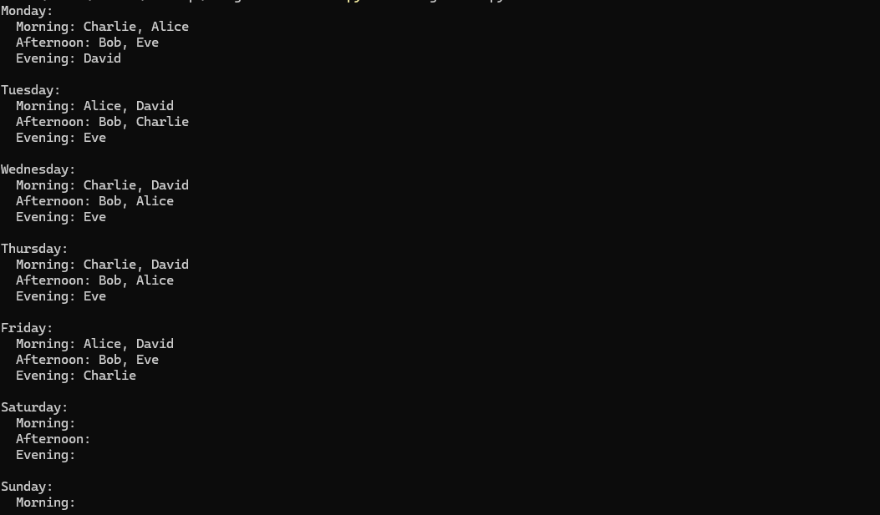

**5. Implementation Details**

**Python Implementation**

Developed an Employee Scheduler that assigns employees to morning, afternoon, or evening shifts while ensuring no employee works more than one shift per day and no more than five days per week (Matthes, 2023). Handles conflicts by reassigning employees if their preferred shift is full. Ensures at least two employees per shift per day.

**Java Implementation**

Implemented a logic that is comparable in Java, using object-oriented programming concepts. Utilizes HashMap and ArrayList for the purpose of managing employees and implementing organized scheduling (Matthes, 2023). Randomized assignments to ensure that the work allocation of employees is balanced while still adhering to requirements.

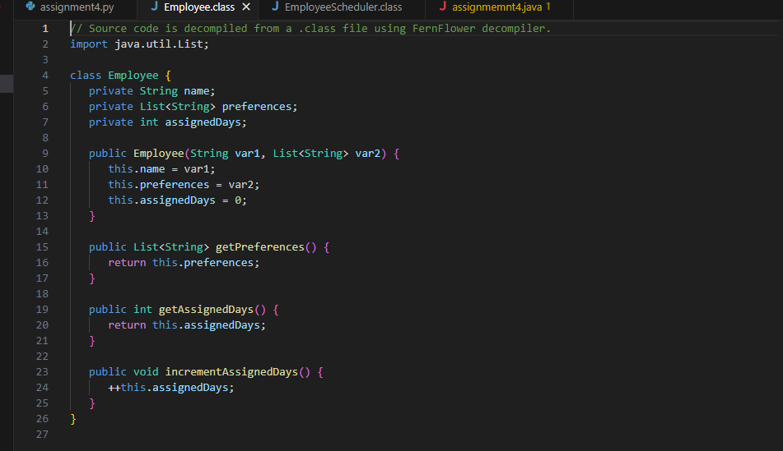

**Conclusion**

The purpose of this project is to demonstrate the significance of control structures in programming by applying them to a problem that is based on the real world, namely staff scheduling. We have proved that we can make efficient use of loops, conditionals, and branching by implementing the solution in both Python and Java (Matthes, 2023). Not only does the solution guarantee that scheduling is fair, but it also resolves issues and satisfies the needs of the firm. This experience highlights the relevance of organized logic in the process of developing software.

**References**

Rosso, R., Wang, X., Liserre, M., Lu, X., & Engelken, S. (2021). Grid-forming converters: Control approaches, grid-synchronization, and future trends—A review. IEEE Open Journal of Industry Applications, 2, 93-109.

Matthes, E. (2023). Python crash course: A hands-on, project-based introduction to programming. no starch press.